1. State transition diagram
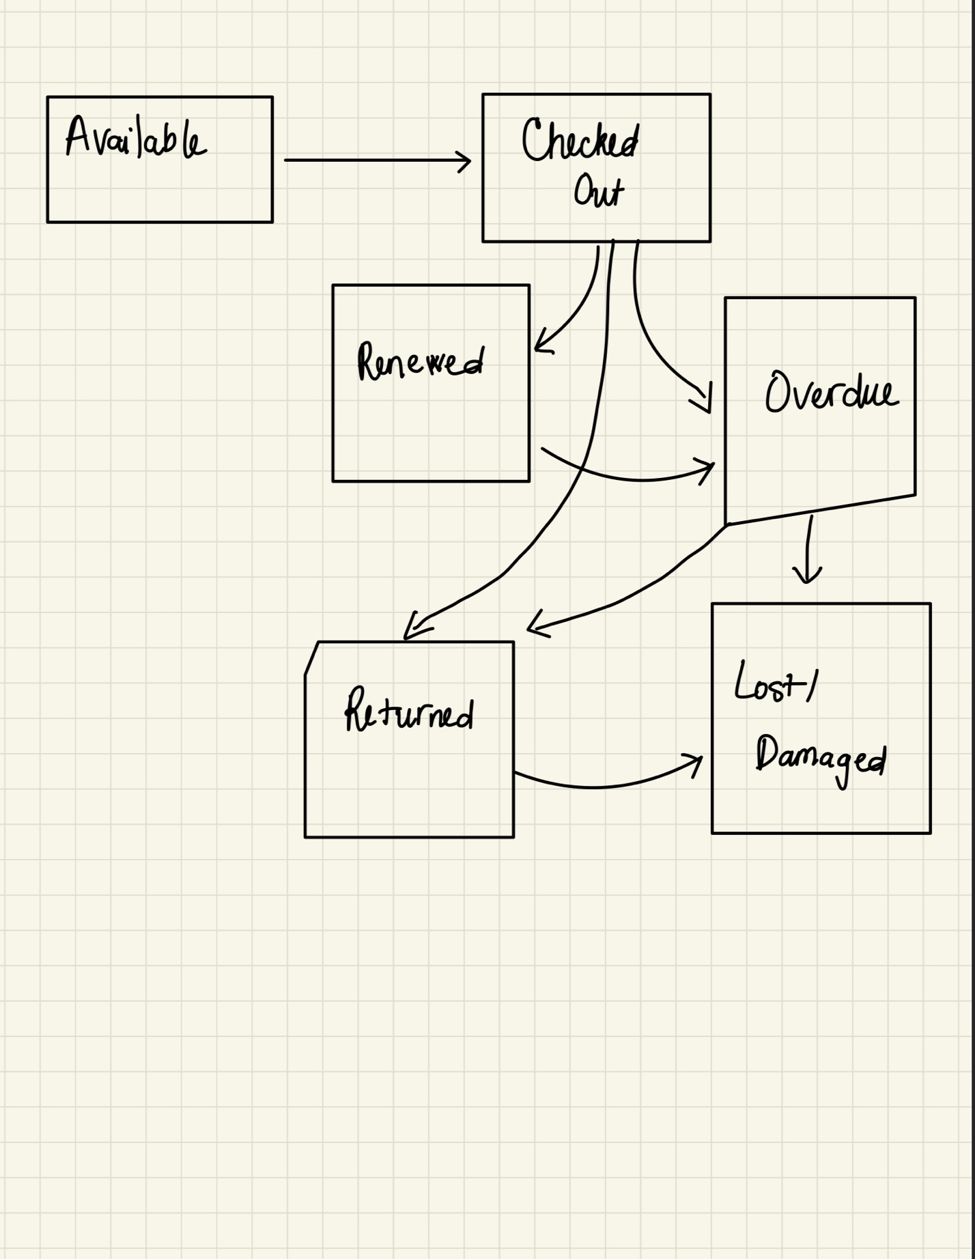

2. State definitions
State | Definition
Available | The book(s) is available to checkout
Checked Out | The book is not available to check out anymore, needs to wait for another reader to return the book
Renewed | The reader extended the loan before the due date. The due date moves forward and the reader keeps the book for a longer period.
Overdue | The due date has passed while the reader still have the book
Returned | The book has been physically checked in by staff or the kiosk.
Lost / Damaged | The book is reported lost (directly from Overdue, no physical return) or found damaged at check-in (from Returned).

3. Key transitions
- Available → Checked Out: checkout request approved.
- Checked Out → Renewed: renewal requested before due date
- Checked Out / Renewed → Overdue: due date passes with no return or renewal.
- Checked Out / Renewed / Overdue → Returned: reader returns the book, on time or late.
- Returned → Available: book checked in and passes condition inspection.
- Returned → Lost/Damaged: book checked in but found damaged.
- Overdue → Lost/Damaged: book reported lost while still outstanding.

